LEXINGTON HIGH SCHOOL
TECHNICAL MATH SYLLABUS 2023-2024
Instructor: Mrs. Peg Fisher School Hours: 7:45 – 3:45 Planning Period: 10:32 a.m. – 11:17 a.m.
Room: 122 E-mail Address: peg.fisher@lexschools.org School Phone: 324-4691 ext. 2122
Prerequisites: MAPS score of 225 (Semester 1) or 234 (Semester 2)

Dual Credit with Lexington High School and Math 1020 Technical Math (3 credit hours) will be issued at successful completion by Central Community College.

Suggested Materials:
- iPad (to be brought to class every day unless otherwise stated)
- Paper
- Pencil w/eraser
- Composition Notebook
- A positive attitude – “If there were one word that could be used to describe a successful person, that one word would be ATTITUDE.”— Bart Starr

Grade Scales:
Lexington High School
A: 93-97/A+: 98-100 B: 85-89/B+: 90-92 C: 77-81/C+: 82-84 D: 70-73/D+:74-76 F: Below 70
Central Community College
A+: 98-100/A: 90-97 B+: 87-89/B: 80-86 C+: 77-79/C: 70 -76 D+: 67-69/D:60-66 F: Below 60

Work will include online homework, quizzes/interactive reading assignments and exams.
Grades will be divided among the following categories:
Homework – 10%
Quizzes/Interactive Reading Assignments – 15%
Exams - 75%
Semester Exam – 10% of Semester grade
— 1st Semester: Quarter 1 = 45% / Quarter 2 = 45% / 1st Semester Test = 10%
— 2nd Semester: Quarter 3 = 45% / Quarter 4 = 45% / 2nd Semester Test = 10%

Homework: Each section within a module has a homework assignment. The homework in each section is required after the reading assignment is completed unless the module pretest or quiz had a score of at least 80%.
Quizzes/Interactive Reading Assignments: Each section within a module starts with an optional quiz. There is only one attempt at each quiz. A score of at least 80% on a quiz will allow a student to move to the next section in the module. If an 80% is not achieved, the student will
proceed to the section’s interactive reading assignment.
Exams will be given over each Module.
A Semester Test will be given each semester. It will cover the content from only that semester. Semester tests cannot be made-up.
Absences: An absent student will have one day plus the number of days missed to turn in homework. A student who misses the day of a test will be required to make up the test the day he/she returns to class. If a student misses the day before the test and the test day, he/she will have the number of days missed to make up the test. Please communicate with me if other arrangements are necessary.
Class Rules and Expectations:
In order to maintain a smoothly running and efficient classroom in which everyone has a chance to succeed, it is expected that you do the following while in class.
- Be enthusiastic and make an effort to learn the material being taught
- Be in your seat with all materials ready when the bell rings
- Be polite and respect the right of the teacher to teach, others to learn, and respect the property of the school and others
- No eating or drinking other than water
- Remain seated until you are dismissed by the teacher
- Scheduling make-up for any work missed is YOUR responsibility

--------------------------------------------------------------------------------------------------------------------------------------
(Please cut on the above line and return signed portion to Mrs. Fisher)

“I have read the syllabus and thoroughly understand with great detail the expectations, rules, and procedures that are expected of me as a student enrolled in this course. I realize that I am responsible for all rules, regulations, procedures, and course requirements set forth in all classes, the LHS student handbook, the LPS student & parent handbook, and the LHS supplement, and I will be held accountable for the contents of this class and supporting documents.”
__________________________________ ___________________________________
Student Name (print) Student Signature
Date ___________________

“I have read thoroughly the contents of this syllabus and discussed with my child the expectations of him/her in this course.”
_______________________________________________________ Date ___________________
Parent / Guardian Signature

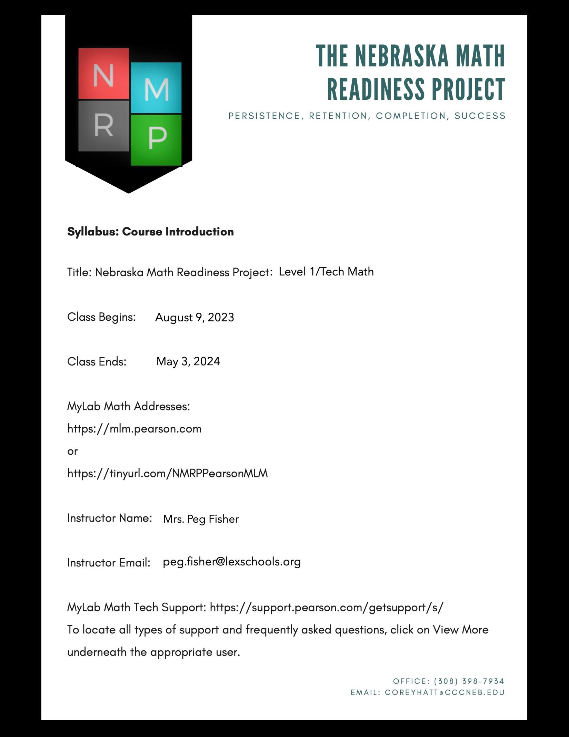
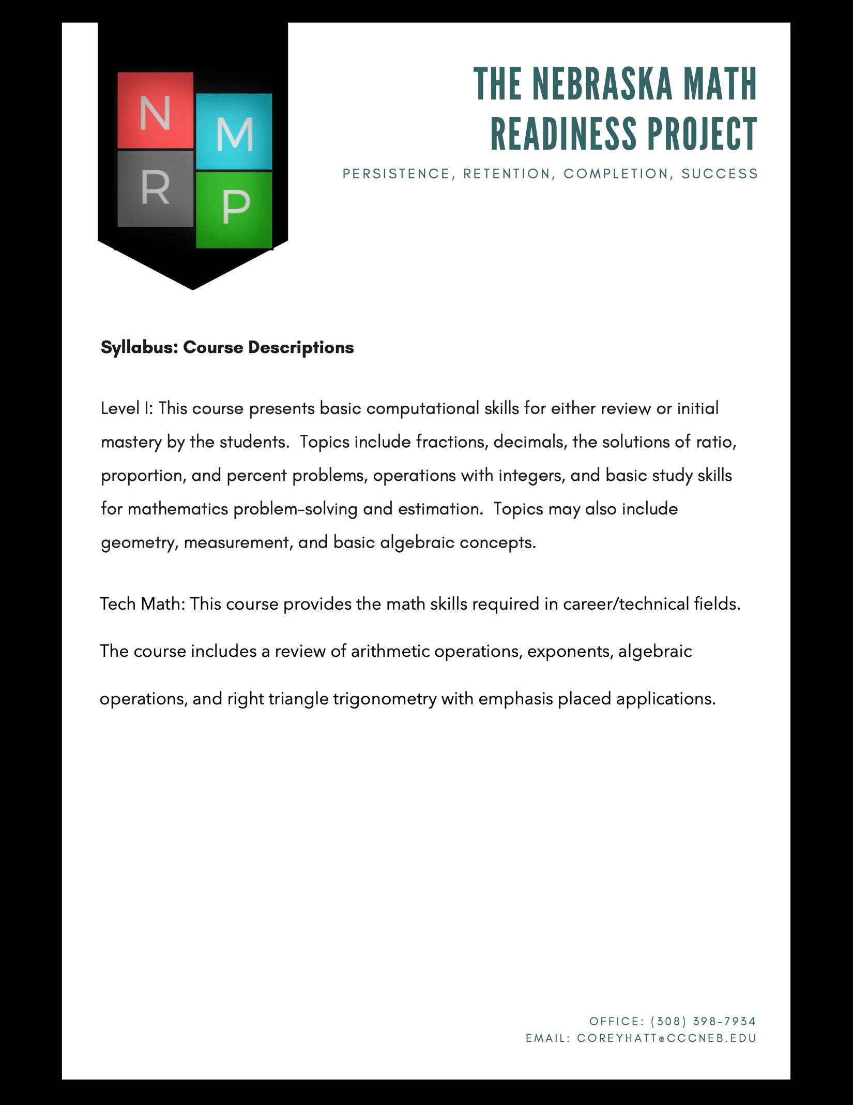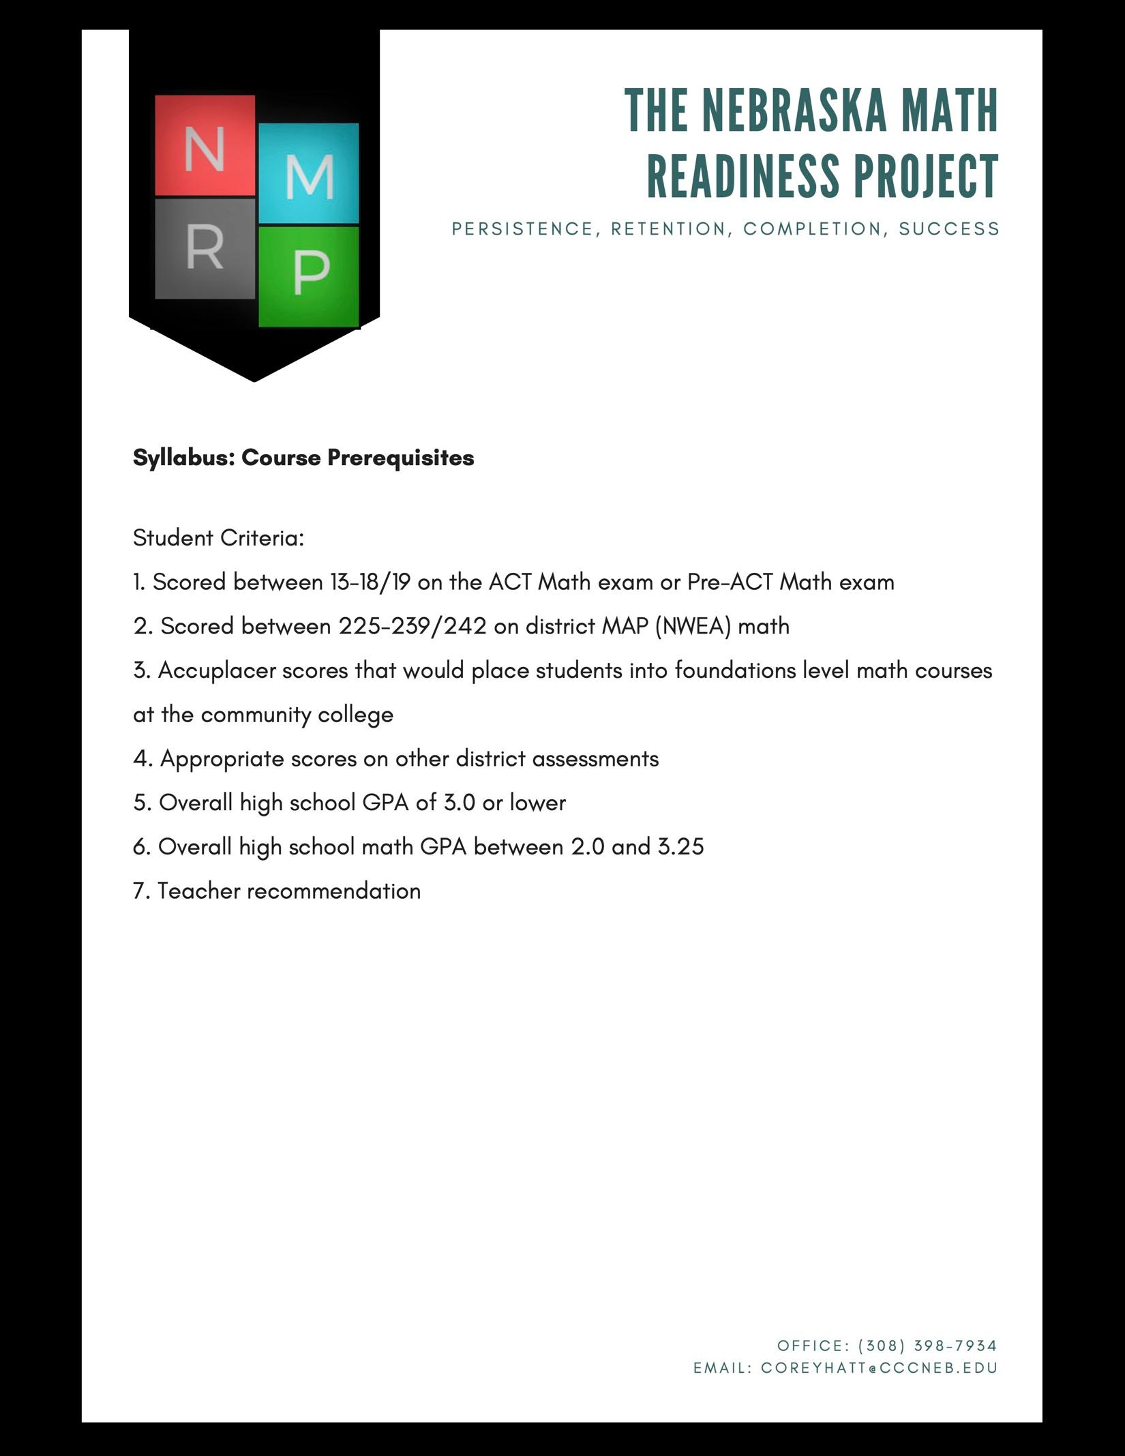
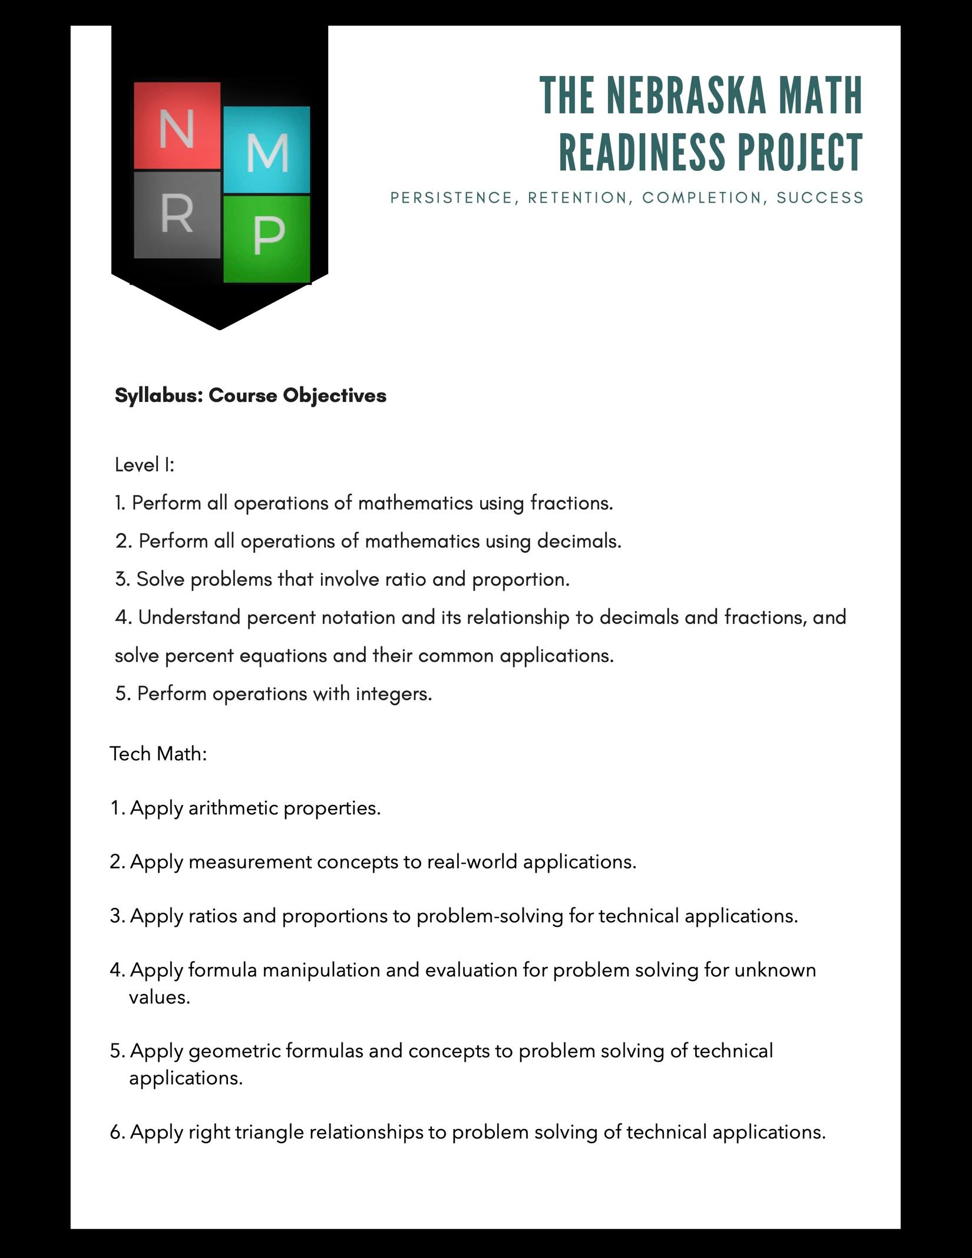
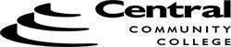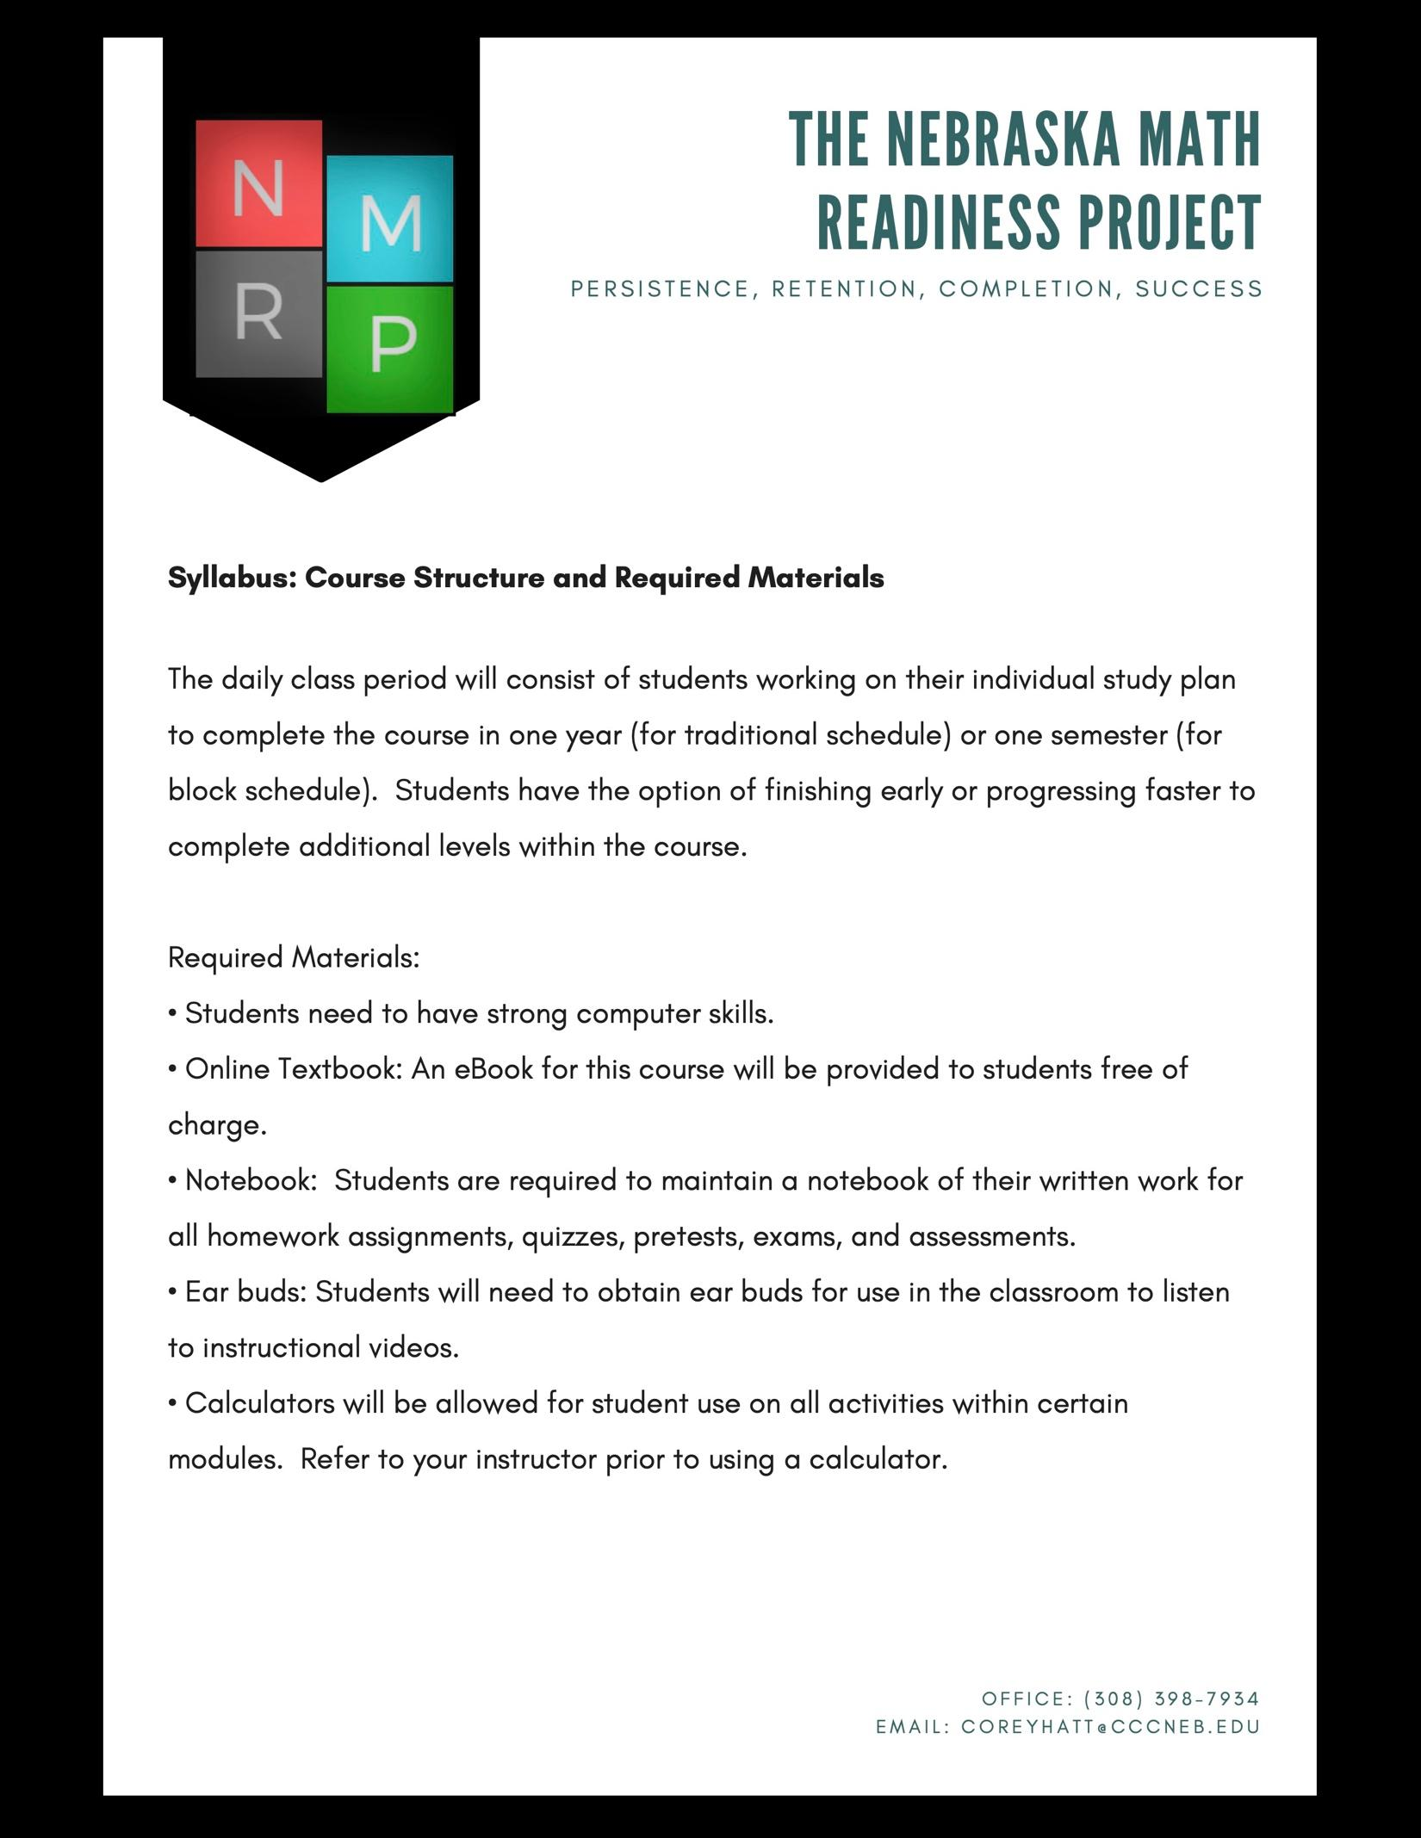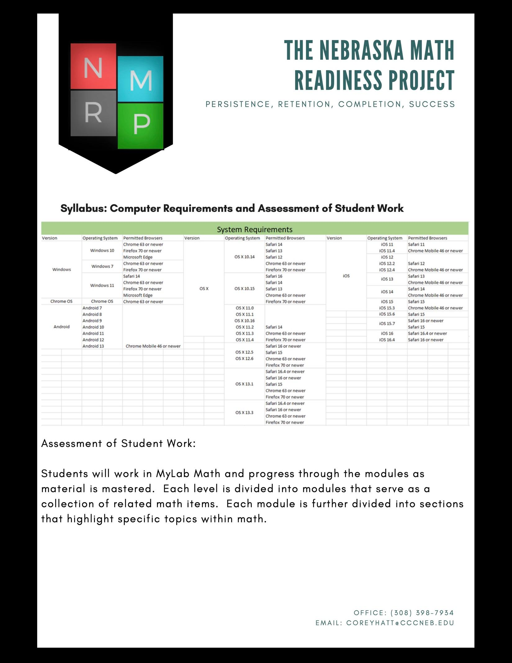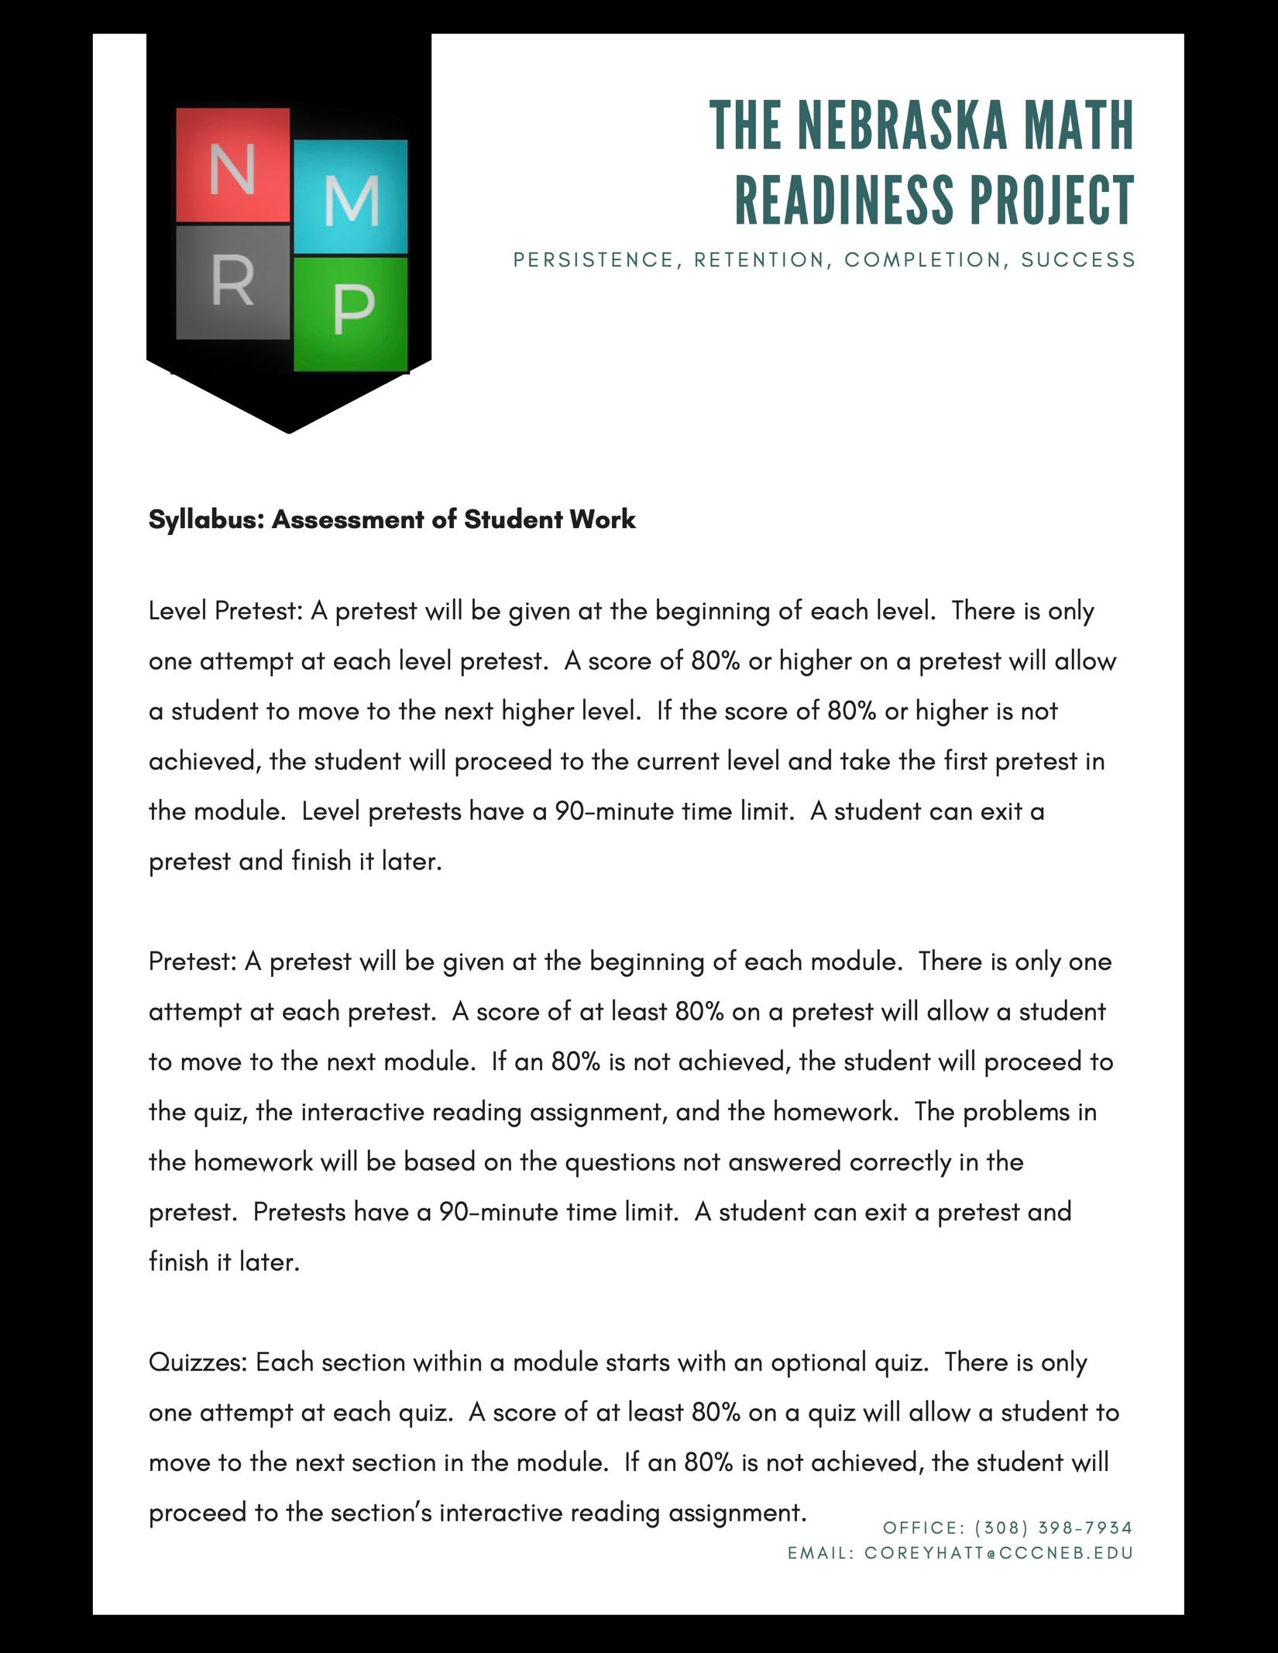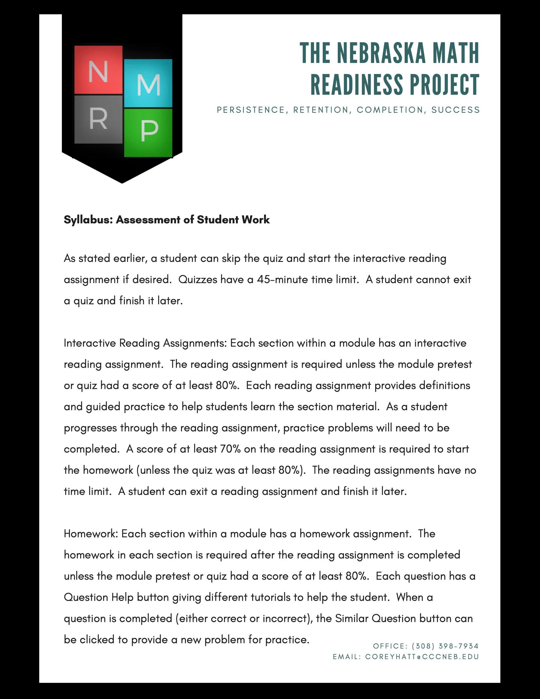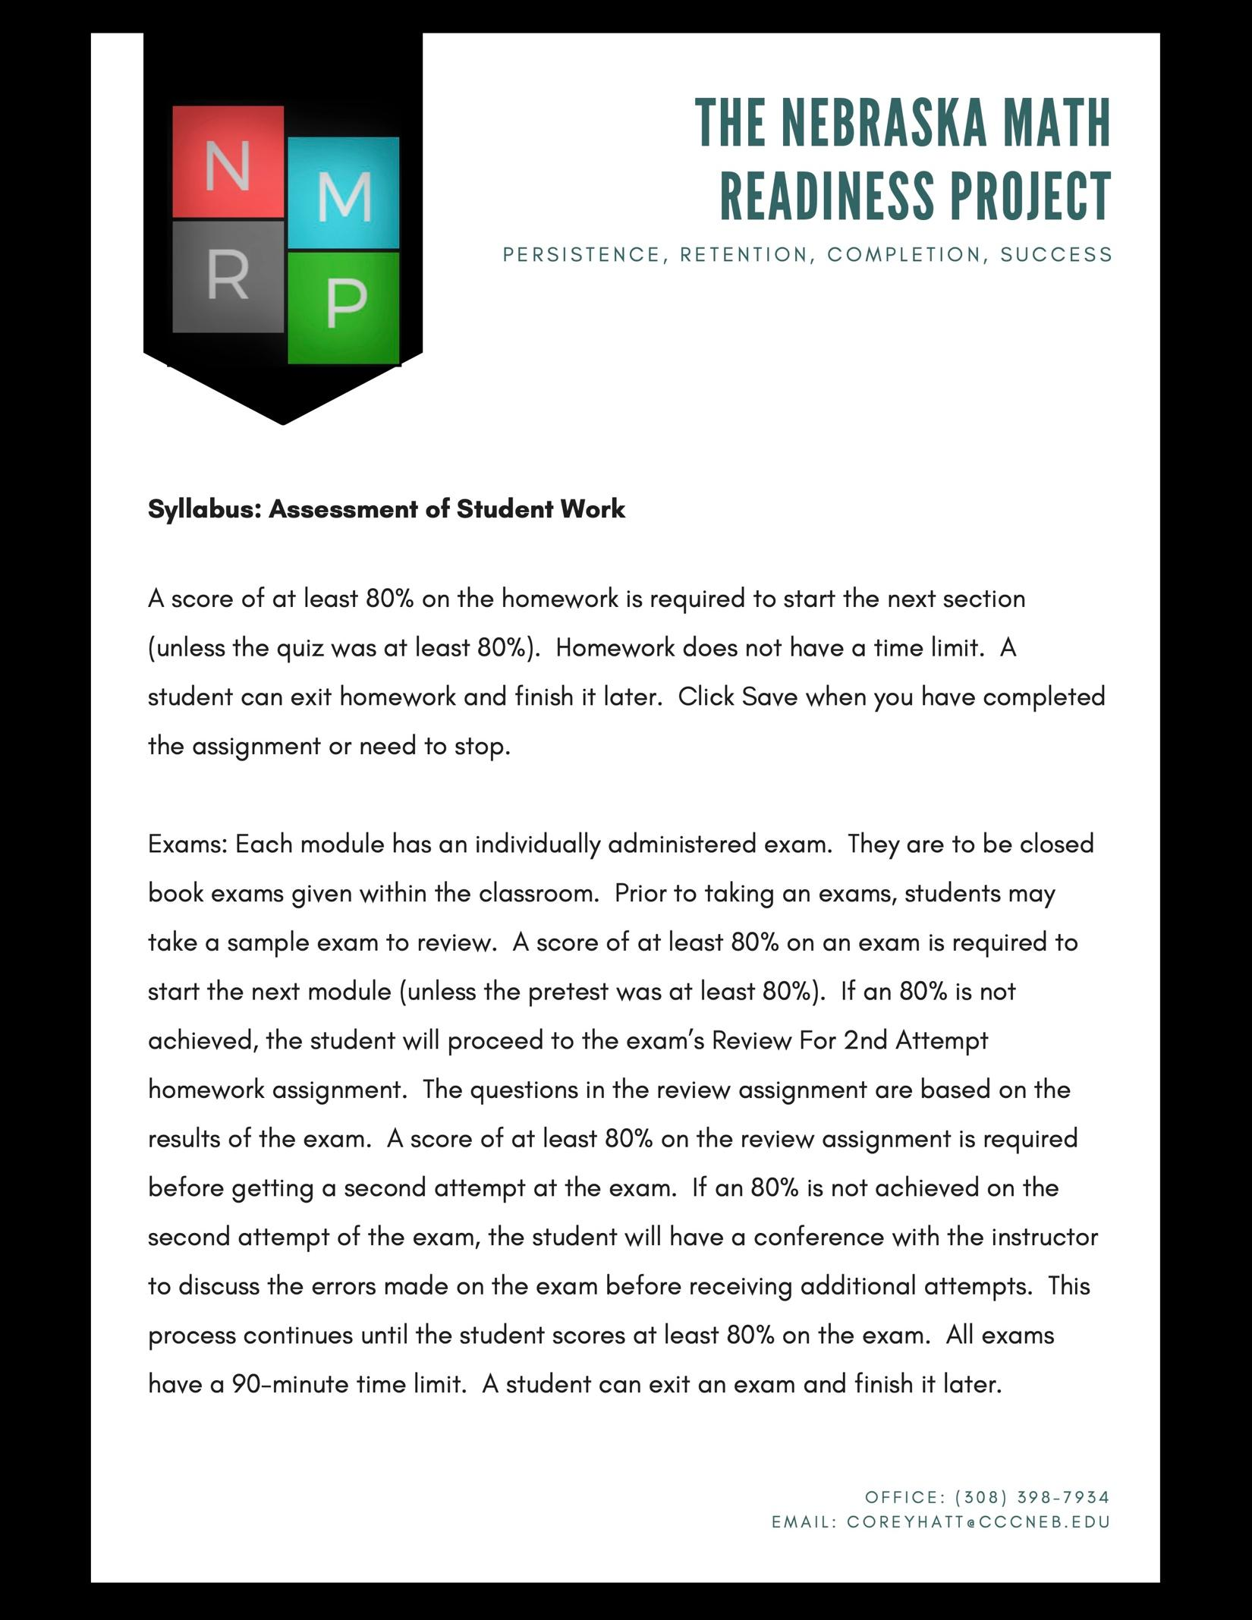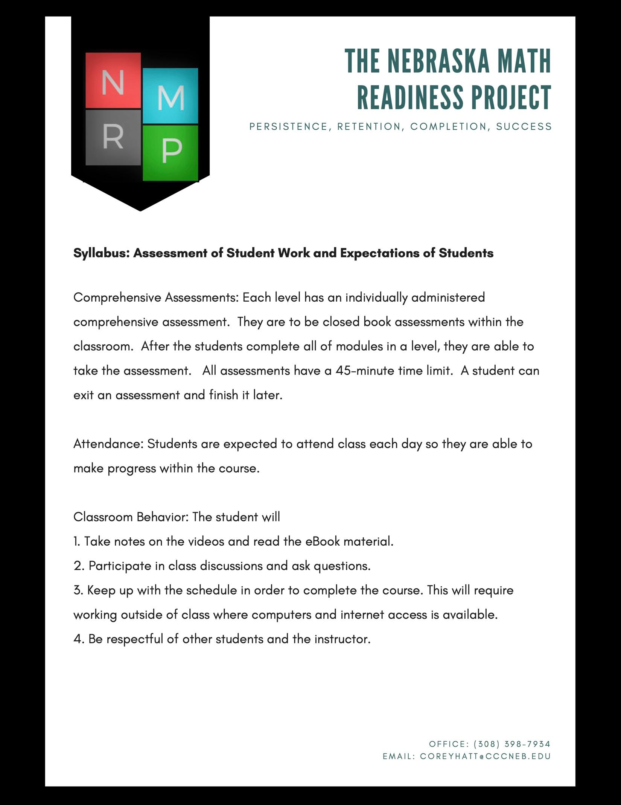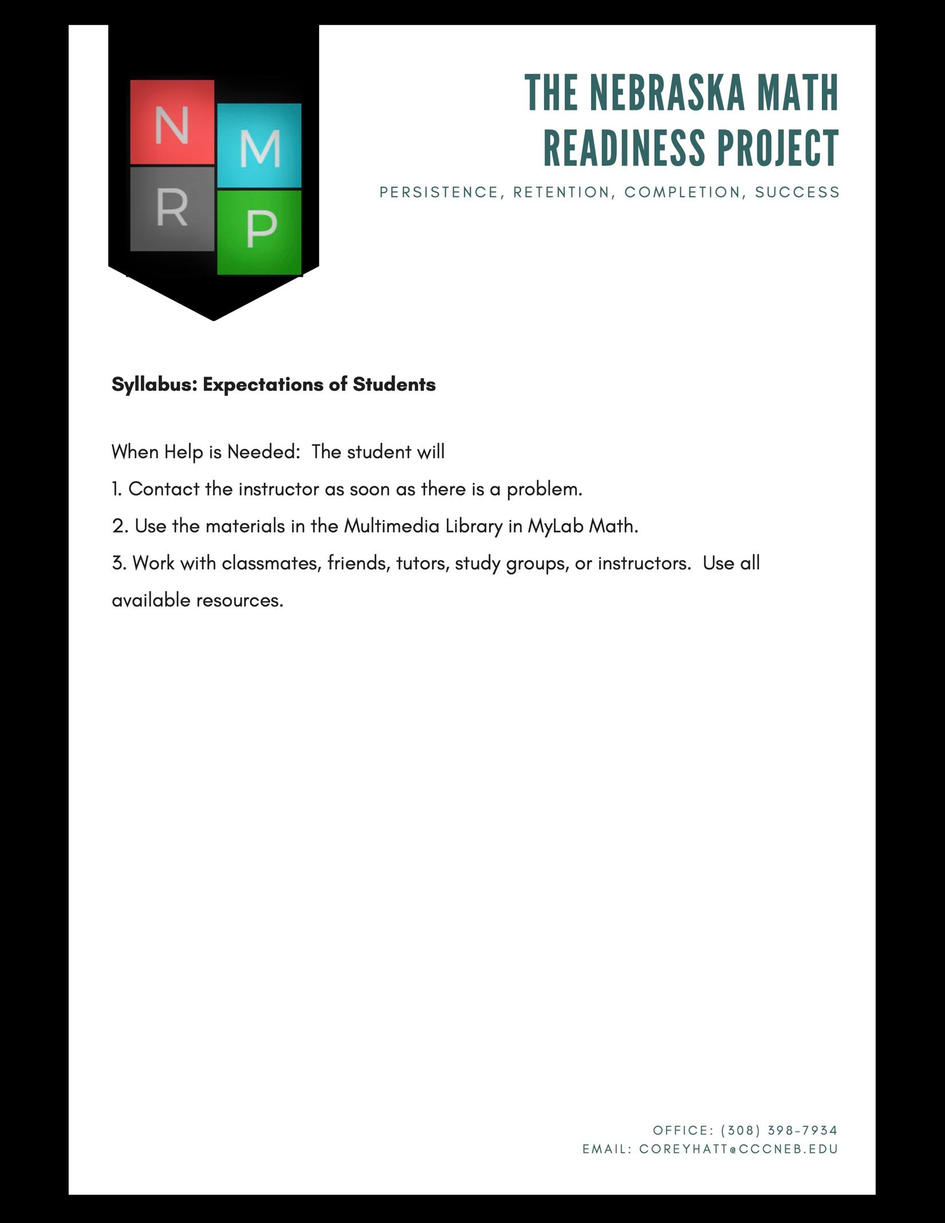
Central Community College
MATH 1020 Technical Math Syllabus (Semester 2)
Course Description
This course provides the math skills required in career/technical fields. The course includes a review of arithmetic operations, exponents, algebraic operations, and right triangle trigonometry with emphasis placed applications.
Total Credits 3

Purpose/Goals
The purpose/goals of this course are to:
Apply arithmetic properties
Apply measurement concepts to real-world applications
Apply ratios and proportions to problem-solving for technical applications
Apply formula manipulation and evaluation for problem solving for unknown values Apply geometric formulas and concepts to problem solving of technical applications Apply right triangle relationships to problem solving of technical applications.

Course Competencies
- Apply arithmetic properties.
Learning Objectives
1.a. Complete basic operations with decimals, fractions and signed numbers.
1.b. Calculate a power or square root of a number.
1.c. Apply the order of operations.
Performance will meet expectations when the student:
1.1. performs calculations with numbers in various forms.
1.2. simplifies expressions involving signed numbers and multiple operations.
2. Apply ratios and proportions to problem-solving of technical applications. Learning Objectives
2.a. Simplify ratios and rates.
2.b. Calculate unit rates.
2.c. Solve a proportion for the unknown value.
2.d. Identify application problems as involving direct or inverse variation.
2.e. Write the proportion or the product equation which correctly represents an application problem.
Performance will meet expectations when the student:
2.1. solves problems involving rates and ratios.
2.2. uses equations to solve problems involving direct and inverse variation.
3. Apply percent concepts to real world applications.
Learning Objectives
3.a. Convert between percent, fraction, and decimal notation.
3.b. Identify the three parts of a percent problem.
3.c. Choose an appropriate formula or method and solve percent problems, including practical applications.
Performance will meet expectations when the student:
3.1. solves problems involving the application of percent.
3.2. solves problems involving percent increase and decrease.
4. Apply measurement concepts to real-world applications.
Learning Objectives
4.a. Convert measurements within and between customary and metric units.
4.b. Read measurements on a ruler, Vernier caliper and micrometer.
4.c. Read meters and gauges with uniform and non-uniform scales.
4.d. Identify the accuracy and precision of a measurement.
4.e. Express calculated answers with the proper number of significant digits or decimal places.
Performance will meet expectations when the student:
4.1. reads measurements in both customary and metric units.
4.2. converts measurements from one unit to another.
4.3. reads measurements from various precision measuring instruments, gauges and analog meters.
4.4. rounds answers to measurement calculations in accordance with accepted rules.
5. Apply formula manipulation and evaluation for problem solving for unknown values.
Learning Objectives
5.a. Evaluate an algebraic expression.
5.b. Simplify an algebraic expression by combining like terms.
5.c. Use the addition and multiplication properties of equality to solve linear equations.
5.d. Solve formulas for a given variable.
5.e. Solve application problems involving linear equations.
Performance will meet expectations when the student:
5.1. employs the properties of equality to solve linear equations and formulas.
5.2. applies mathematical relationships and concepts to problem solving of technical applications.

6. Convert the expression of a linear relationship between equation and graphical forms.
Learning Objectives
6.a. Identify the slope of a linear graph or equation.
6.b. Graph the solution of a linear equation in two variables.
6.c. Use the properties of a linear graph to write its equation.
Performance will meet expectations when the student:
6.1. produces a linear graph from an equation or other given properties.
6.2. identifies properties of a linear graph and uses it to create the corresponding equation.
7. Apply geometric formulas and concepts to solving of technical applications. Learning Objectives
7.a. Calculate the perimeter of polygons.
7.b. Calculate the circumference and area of a circle.
7.c. Calculate the area of rectangles and triangles.
7.d. Calculate volume as area times height.
7.e. Determine the unknown angle of a triangle.
7.f. Determine unknown angles formed by a transversal of parallel lines.
Performance will meet expectations when the student:
7.1. calculates various measures of different geometrical shapes.
7.2. determines the values of unknown angles in various geometrical structures.
8. Apply right triangle (trigonometric) relationships to problem solving of technical applications.
Learning Objectives
8.a. Apply the Pythagorean Theorem in finding an unknown side of a right triangle.
8.b. Calculate unknown values of a right triangle by use of sine, cosine and tangent ratios.
8.c. Solve oblique triangles by use of the law of sines and the law of cosines.
Performance will meet expectations when the student:
8.1. determines the unknown sides and angles in right and oblique triangles.
9. Analyze statistical data.
Learning Objectives
9.a. Read data from various types of graphs.
9.b. Display data in graphical form.
9.c. Calculate data relationships.
9.d. Calculate the mean, median and mode of a set of numbers
Performance will meet expectations when the student:
9.1. analyzes data from a graph.
9.2. describes data by measures of central tendency.

CCC-Americans with Disabilities Act
If you have a disability or want to know if you qualify for accommodations as defined by the Americans with Disabilities Act, you are invited to contact the campus Director of Disability Support Services. You are not required to disclose or reveal information about your disability to anyone at any time, however, in order to receive accommodations in college, you must make those needs known and request services from the Disability Support Services office on one of the three CCC campuses. Inquiries concerning the application of the laws and regulations cited above may be directed to the Human Resources Office, Central Community College, P.O. Box 4903, Grand Island, NE 68802-4903; (308) 398-7325, or to the Director, Office of Civil Rights, U.S. Department of Education, Washington, DC 20201.

CCC-Archiving of Student Work
To protect the original work of students from plagiarism and to uphold the high academic standards and integrity of CCC, any written assignment in this course may be submitted to an internet-based plagiarism detection service such as Turnitin.com by the student or the instructor. All submitted written assignments will be archived and may be referenced for the purpose of detecting plagiarism.
CCC-Course Meeting Time and Location
Course meeting time and location may be found in WebCentral through My Services, Services for Students,
Academic Planning, Student Planning, Go to Plan & Schedule, Timeline tab or use this quick link: Student Planning Timeline Tab > Sign In, if applicable > Navigate to Term > Click on Course Name

CCC-Equal Opportunity/Affirmative Action
Central Community College does not discriminate on the basis of race, religion, national origin, gender, age, disability, marital status, or military veteran status as is defined by law in employment, admission, scholarship and financial aid programs or operation of its educational programs and activities as prescribed by Titles VI and VII of the Civil Rights Act of 1964, Title IX of the Education Amendments of 1972, Executive Order 11246 as amended, sections 503 and 504 of the Rehabilitation Act of 1973, the Vietnam Era Veteran’s Readjustment Assistance Act of 1974, the Age Discrimination Acts of 1974 and 1975, and other federal and state laws and regulations.
Central Community College offers career and technical education programs for all students regardless of race, color, national origin, age, religion, marital status, including those with limited English proficiency, sex or disability. For a complete list of programs, go to www.cccneb.edu/programs. Educational programs are offered at but not limited to the following locations: Columbus Campus, Grand Island Campus, Hastings Campus, Holdrege Center, Kearney Center, Lexington Center and Ord Learning Center.

CCC-Expectations for Academic Integrity
Central Community College believes successful students are independent critical thinkers who possess the work ethic and skills necessary to make a positive difference in their professions and communities. In order to maximize student and community success, CCC is devoted to maintaining an honest academic environment and upholding integrity as a core value. All individuals across all course modalities are expected to practice academic integrity, which encompasses the fundamental values of honesty, trust, respect, fairness, and responsibility. In the case of alleged violations of academic integrity, Central Community College strives for fair resolution.

Instances of Academic Dishonesty:
Behaviors that violate the fundamental values of academic integrity at Central Community College may include but are not limited to the following:
∙ Plagiarism - direct copying or paraphrasing without citation someone else’s work (i.e. writing, images, video or audio)
∙ Cheating - engaging in any behavior intended to achieve an unfair advantage for self or another in any academic exercise (i.e. unauthorized collaboration or unauthorized use of resources or data in a study)
∙ Fabricating Information - inventing or falsifying information (i.e. making up resources and/or citations, falsifying academic records)
∙ Facilitating Academic Dishonesty - soliciting, furnishing, or offering to furnish unauthorized exams, quizzes, or academic materials; participating in academic sabotage
Read the Expectations for Academic Integrity in its entirety.

CCC-General Information
All college policies and procedures identified in the student handbook will be adhered to for the course. College policies and procedures include, but are not limited to, conditions for dropping or withdrawing from a class, student academic honesty, etc. A copy of the student handbook is available upon request from the Student Services office on each campus or you may utilize this link to the Student Handbook.

CCC-Technology Usage Guidelines
In order to support the activities for this course, Central Community College provides access to computers for students. The College established Technology Use Policy and Procedure documentation. This document can be found on the College web site. You may click this link to download a PDF document outlining the College's Technology Use Guidelines.

CCC-Title IX Policy
Members of the Central Community College community, guests and visitors have the right to be free from all forms of gender and sex-based discrimination, examples of which can include acts of sexual violence, sexual harassment, domestic violence, dating violence, and stalking. All members of the campus community are expected to conduct themselves in a manner that does not infringe upon the rights of others. Any member of the community, guest or visitor who believes that the policy on Equal Opportunity, Harassment and Nondiscrimination has been violated should contact the Title IX/Equity/AA Coordinator, Dr. Marcie Kemnitz, 308-398-7400 or mkemnitz@cccneb.edu. Students should understand that in cases of gender and sex-based discrimination, no College employee, including members of the faculty, can guarantee confidentiality. For more information about CCC’s policy please reference CCC’s Title IX Handbook. For counseling services which may remain confidential, CCC has contracted with the Family Resource Center for counseling services for CCC students at no cost. To schedule an appointment, call 1- 888-381-7487, www.family-resources.net.

